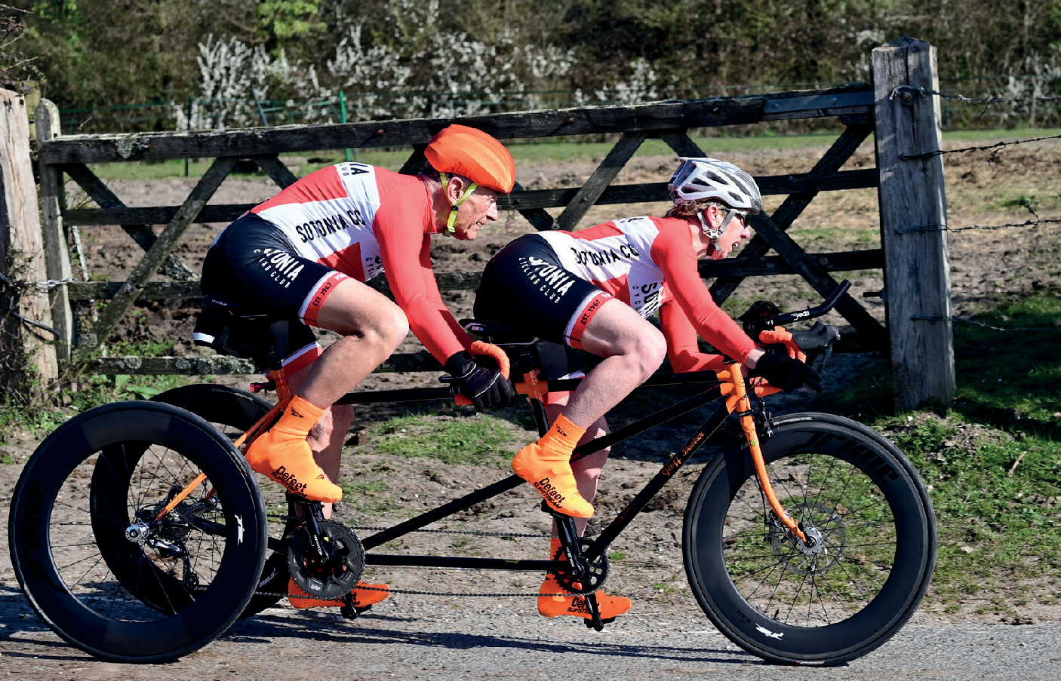

**Open 10 Mile Time Trial**

**Sunday 14th July 2024 | Course P612/10**

**Promoted for and on behalf of Cycling Time Trials under their Rules and Regulations**

**Timekeepers:** Mary Corbett, Norman Harvey, Dave Crocker, Julian Gee

Sotonia CC

**Recorder:**

**Organiser:** Graham Harman 16 Woodman Close, Sparsholt, Winchester, Hants, SO21 2NT

**07769437843**

**Event headquarters:**

**Picket Twenty Community Centre**

**Picket Twenty Way, Andover, SP11 6TY**

**HQ will open from 07.00**



IN THE INTERESTS OF YOUR OWN SAFETY, Cycling Time Trials and the event promoters strongly advise you to wear a HARD-SHELL HELMET that meets an internationally accepted safety standard. It is also compulsory that WORKING FRONT & REAR LIGHTS, either flashing or constant, are fitted to the machine in a position visible to following road users and is active while the machine is in use.

There may be no pusher-offered; you will have to do a standing start on your own (one foot on the ground). Rolling starts will not be permitted.

Once you have finished your race you will be asked to return your number & sign out, back at the HQ for a tea/coffee and cake.

No warming up on the course once the event has started.

Heads up please, accidents down.

**Parking**

There is parking available at Picket Twenty Community Centre

**Prizes**

**Male Female Road Bike Vet on STD**

1st £30 £30 £30 £30

2nd £20 £20 £20 £20

3rd £10 £10 £10 £10

**Fastest Team of 3** £30



**Route to start**

When leaving the HQ turn right and follow Picket Twenty Way which bears right and then left heading out of Picket Twenty back towards the A303 the start line is just before you exit the Picket Twenty estate.

**Route from finish back to HQ**

After finishing your race continue along A303 and turn off on next exit slip road A3093 (small climb)

Continue along this road to the 1st roundabout where you turn right passing the start area into Picket Twenty Way then turn right and follow road around to right heading back to the HQ

# Course description

# Start at drain cover at Picket Twenty road just off roundabout. Turn left and proceed to entry left to join A303(t) Andover bypass eastbound carriageway (gr385450). Travel eastbound on A303(t) for approx 6 miles where take slip road at Bullington Cross (A34 northbound/southbound). At roundabout stay in left hand lane to take 1st exist and follow road under A34 and A303(t) to turn left at next junction and rejoin A303(t) in westbound direction. Retrace westbound along A303(t) to finish at lay-by 10 mile point, approx 1 mile before slip road onto A3093 (riders not to stop at finish but continue riding and leave A303(t) at A3093 exit).